The Cornwall Holiday Home Owner’s Quick Guide to Selling Privately
A simple 2-page guide for caravan & lodge owners in Cornwall
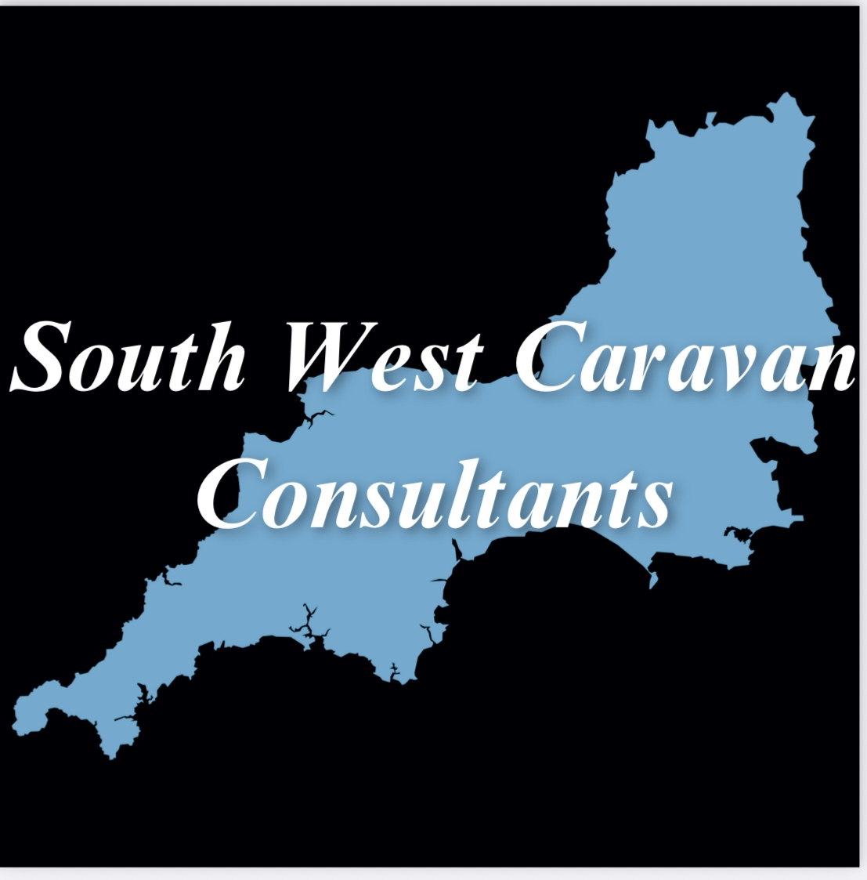
Southwest Caravan Consultants | holidayhomesincornwall.co.uk

Can You Sell Privately?
Most owners can sell privately. Parks usually approve the buyer, handle paperwork, and charge commission. Private sales often achieve stronger prices than park trade-ins.
Why Sell Privately?
- Better sale price
- More control over the process
- Transparent agreement between buyer and seller
What Affects Your Sale Price?
- Make & model
- Age & condition
- Pitch location
- Remaining licence years
- Park popularity
- Comparable sales
Simple Steps to Prepare Your Holiday Home
- Clean and declutter
- Check appliances
- Tidy decking/outdoor areas
- Gather manuals & certificates
How the Process Works
1. Market your holiday home
2. Arrange viewings
3. Buyer completes park approval
4. Transfer meeting & paperwork
5. Commission deducted, sale completes
Thinking of Selling?
We help owners across Cornwall achieve the best possible price with a simple, transparent process.
Thinking of selling your caravan or lodge? Get friendly, expert advice today.
David Wright | Southwest Caravan Consultants
holidayhomesincornwall.co.uk

